Department of Mechanical Engineering

EMCH 368
MECHATRONICS

Lab 4
LCD

Last Edited 06/23/24 by T. Russo
A seven-segment display is a device used to show numbers. It has seven LEDs arranged in the shape of the number 8. Each LED is called a segment, and they are labeled from 'a' to 'g'.
To display numbers, specific segments are lit up in different combinations. For example, to show the number 1, only segments 'b' and 'c' are lit.
The display usually has ten pins: two are common pins connected to either ground or power, and the other eight are for each segment (a-g) and the decimal point (DP). By controlling which segments light up, you can display any digit from 0 to 9.

An LCD (liquid crystal display) screen is used to display alphanumeric characters. The LCD screen in this kit features 16 columns and 2 rows for 32 characters. See the data sheet attached to this lab for more details.

A tilt switch/sensor will open close depending on its orientation. Typically, they are hollow cylinders with a metal ball inside that will make a connection across two leads when tilted in the proper direction. On the tilt switch, there is an arrow indicating the “up direction” where the switch should be facing the breadboard.

A potentiometer is a variable resistor with three pins. Two of the pins are connected to the ends of a fixed resistor. The middle pin, or wiper, moves across the resistor, dividing it into two halves. When the external sides of the potentiometer are connected to voltage and ground, the middle leg will give the difference in voltage as you turn the knob.

Exercise 1: Create a 7-segment display that shows the output from a potentiometer
A 7-digit segment display is a simple display for easily providing numerical results. It can be used for a variety of tasks from a countdown, displaying temperature, or anything that needs only a numerical display. A potentiometer is a variable resistor that can be used for a multitude of projects that need a dial for user input like a volume control. In this exercise, you will learn to use a library to control a 4 digit 7-segment display that will show the output from a potentiometer. A library in code is a collection of pre-written code that you can use to simplify tasks and add functionality to your programs. It is used to save time, avoid reinventing the wheel, and ensure your code is more efficient and reliable.
Materials:
- 1 set of long red and black jumper wires
- 1 4-digit 7 segment display
- 4 1k Ohm Resistors
- 1 potentiometer
- Wires
Building the Circuit:
- Connect a red wire to the 5V pin and put the other end in one of the long (+) bus lines in the breadboard.
- Connect a black wire to the ground pin to the adjacent long (-) bus line on the breadboard.
- Place the 4-digit 7-segment display on the breadboard, ensuring each pin is in a separate row.
- Using the diagram provided below, connect pins E, D, DP, C, G, A, F, B to digital pins 6,5,4,3,7,9,8,2, respectively.
- For pins, D1, D2, D3, and D4, first wire them to 1k resistors then from the resistors, wire to digital pins 10, 11, 12, 13, respectively.
- Lastly, place a potentiometer on the board, wire power to one end and ground the other end. Wire the middle pin to analog pin A0.

Writing The Code:
Including the library, this brings in code from a different source, so you do not have to code it yourself. Start initializing your variables that will be used later in the code. This library does not come standard with the coding platform. Go to the menu bar and click on Sketch. Select Include Library from the dropdown menu. Click on Manage Libraries.... In the Library Manager window, type SevSeg in the search bar. Find the SevSeg library by Dean Reading in the list and click the Install button.

Start the setup function of your code, begin the serial monitor to follow the value read from the potentiometer. Create a list that holds the values for both the digits, and the segments of those digits.
Using the Boolean values set up resistors on segments which tell the device that resistors are being used. UpdateWithDelaysIn updates with delays being in the code. Similar to beginning Serial monitor, begin the sevseg.
Read the value from the potentiometer, then set the number given to the display.

Exercise 2: Create an interactive LCD program that generates random responses
An LCD screen is a useful tool for providing visible results. It can be used for a wide variety of tasks including telling the future! Well not actually telling the future, but like a Magic8 Ball, it can randomly provide answers to questions you ask. By using a random number generator and variety of cases correlating to the numbers generated, the microcontroller can provide a variety of answers that you define! Using a tilt switch, the shaking of a Magic8 Ball can also be emulated. Used properly, tilting the board will cause the microcontroller to provide a new random answer to all of life’s greatest questions that you decide to ask it. The LiquidCrystal library that comes with the Arduino software handles all the writing to the LCD’s pins and simplifies the process of writing software to display the characters. All you need to do is wire up the LCD properly.

Your goal is to create a circuit that meets the following criteria:
- Uses an LCD screen to display text. Specifically, the random answers to the user’s questions
- The contrast of the LCD screen is adjustable using a potentiometer
- Begin the program with an introductory text, prompting the user to “ask the Crystal Ball”
- Provide 8 cases for a random output whenever the board is shaken. These can range from “Yes” to “No” to “Maybe someday…”
- Use a tilt switch to emulate the shaking of a Magic8 ball. When shaken, the microcontroller will provide a different answer
Materials:
- 1 set of long red and black jumper wires
- 1 tilt switch
- 1 10k-ohm resistor
- 1 LCD
- 1 potentiometer
- 1 220-ohm resistor
Building the Circuit:
Note: This circuit is not overly complex, but there are a lot of wires. Pay close attention that you are wiring up everything correctly, so you don’t fry the LCD screen. Ask the instructor for assistance if needed.
- Connect a red wire to the 5V pin and put the other end in one of the long (+) bus lines in the breadboard.
- Connect a black wire to the ground pin to the adjacent long (-) bus line on the breadboard.
- Place the tilt switch on the breadboard and connect one end to power. Connect the other end to ground through a 10-kilohm resistor and digital pin 6.
- Place the potentiometer across the breadboard with the top leg connected to power and the bottom grounded. Connect the middle potentiometer pin to the V0 pin of the LCD. This will allow you to control the contrast of the screen using the dial of the potentiometer
- Connect LCD pins VSS and K to the ground. Also connect the R/W pin to ground to put the LCD in writing mode
- Connect LCD pin VCC (or sometimes labeled VDD) to power.
- Connect LCD pin A to power through a 220-ohm resistor.
- The state of the following pins (low or high) are the bits that you are writing to the register. Each character has its own “code” made up of a combination of HIGH/LOW values from the microcontroller. Connect the following data pins:
  - Digital pin 2 to LCD D7
  - Digital pin 3 to LCD D6
  - Digital pin 4 to LCD D5
  - Digital pin 5 to LCD D4
- Connect LCD pin EN (or labeled E) to digital pin 11. This pin enables the signal to be written on the register.
- Connect LCD pin RS to digital pin 12. This pin controls where in the LCD’s memory you are writing data to. You can select either the data register, which holds whatever is put on the screen, or an instruction register, where the LCD’s controller looks for instructions on what to do next.
- Connect to USB to upload your code
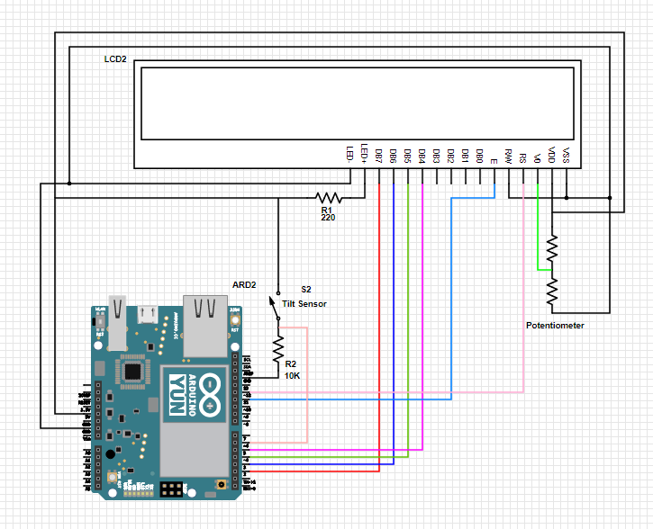

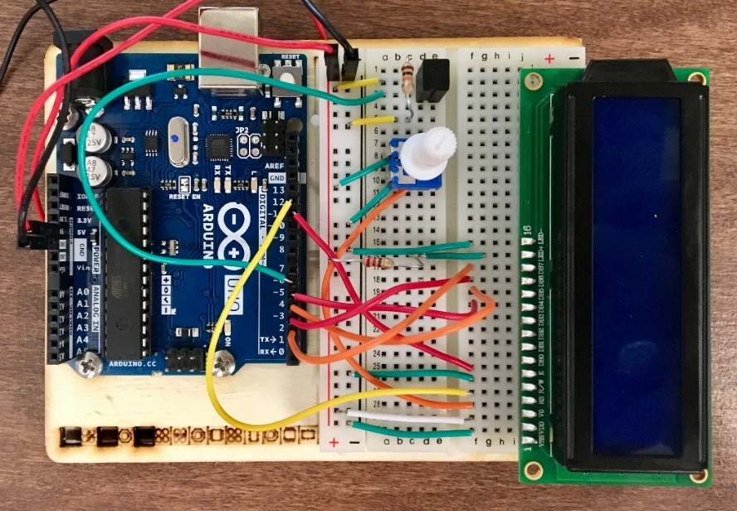
Exercise 2 Circuit
Writing the Program:

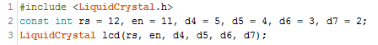

First, we need to import the LiquidCrystal library and tell it which pins it will be using to communicate. The LiquidCrystal library that comes with the Arduino software handles all the writing to these pins and really simplifies the process of writing code to display characters on the screen. Notice that by putting commas between each variable, they all take on the const int attribute. This just saves time and space in the code.

Next, we need to create some constants and variables like we have done before in other sketches. In this case you will need a constant to hold the pin number of the tilt switch, a variable for the current state of the switch (open = 0, closed = 1), a variable for the previous state of the switch, and a variable for selecting which of the random replies which will appear on the LCD.

Define the switch pin as an input using pinMode() within the setup(). Start the LCD library by defining the size of the screen using the lcd.begin command. We are telling the lcd object that it has 16 columns and 2 rows.

Now we want to tell the LCD screen what to say. Begin with using the print() function to write the text for the first line of the LCD screen. Move the cursor down to the second line of the LCD using lcd.setCursor(). Remember, computers are zero indexed so 0,0 is the first column of the first row. Print the text for the second line.

Within the loop(), define the switchState by checking the switch pin. Next use an if() statement to determine if the switch is in a different position than it was in before so we know it has been shaken. != means NOT EQUAL TO. The microcontroller is reading the current state of the switch and comparing it to the previous state of the switch. If the state has changed from HIGH to LOW, you know that the ball has been tilted from one direction to the other. The variable reply is then assigned a random integer from 0-7.
Before we can define the eight random statements, we must clear the screen with the function lcd.clear() and define a new statement for the first row. This is done by setting the cursor back at 0,0 and using the lcd.print() function to print the line “The ball says.” We can now move the cursor to the second row and begin defining the responses.
The switch() statement will execute different lines of code depending on the value it is given by the random number generated for reply. Each of these different executables is called a case. The different messages are put within the eight cases defined in the code. The case function is followed by lcd.print() which again tells the LCD screen what to say. It is then followed by break which tells it has reached the end of the case. Then, another case can begin.

Finally, we have reached the end of the loop(). Before we exit loop(), we redefine the prevSwitchState as the current switchState so that when the program iterates through the loop() again it will know what the switch state was for the iteration we are now finishing.

Use the circuit:
After downloading the code, the program begins. The intro screen should appear with “Ask the Crystal Ball!” By shaking the board, the LCD screen should change and “The ball says” should appear on the first line. The second line will randomly display one of the eight responses you programmed. The tilt switch might be sensitive, and just tapping the board instead of shaking it might do the trick.
If your screen does not display anything, you may need to turn up the contrast. Turn the potentiometer until you can clearly see the text.

Exercise 3: Creating an LCD Stopwatch
Not only can the LCD tell the future, but it can also tell time! You have now seen by using the circuit board inputs (e.g., potentiometer, tilt switch), you can change the display on the LCD, creating an interactive experience. In this next exercise, you will create an interface that allows you to stop and start a timer at the push of a button. In addition, you can track your “lap time” by adding a second button that when pressed, tells you how long it has been since the last time you pressed it.
Your goal is to create a circuit that meets the following criteria:
- The contrast of the LCD screen is adjustable using a potentiometer
- When turned on, the LCD displays an introductory screen that prompts the user to start the timer
- By pressing a “start” button, a timer showing min:sec appears on the top line of the LCD
- By pressing a “lap” button, the second line of the LCD displays how long it has been since the last time the lap button was pressed
- Whenever the start button is pressed again, the timer pauses. The button can be used to resume/pause the stopwatch at any time
Materials:
- 1 set of long red and black jumper wires
- 1 potentiometer
- 1 LCD
- 2 switches
- 2 10k-ohm resistors
- 1 220ohm resistor

Building the Circuit:
Note: This circuit is not very complex, but there are a lot of wires. Pay close attention that you are wiring up everything correctly, so you don’t fry the LCD screen. Ask the instructor for assistance if needed.
- Remove USB power before tampering with the circuit
- Remove all components directly connected to the tilt switch. Keep the potentiometer and the LCD with all its connections
- Place a pushbutton across the gap of the breadboard. Connect one side to 5V power. Connect the other side to digital pin 6 and ground with a 10-kilohm resistor. This will act as the start/pause button
- Place a second pushbutton across the gap of the breadboard. Connect one side to 5V power. Connect the other side to digital pin 7 as well as to ground with a 10-kilohm resistor. This will act as the lap button.
- Connect to USB to upload your code
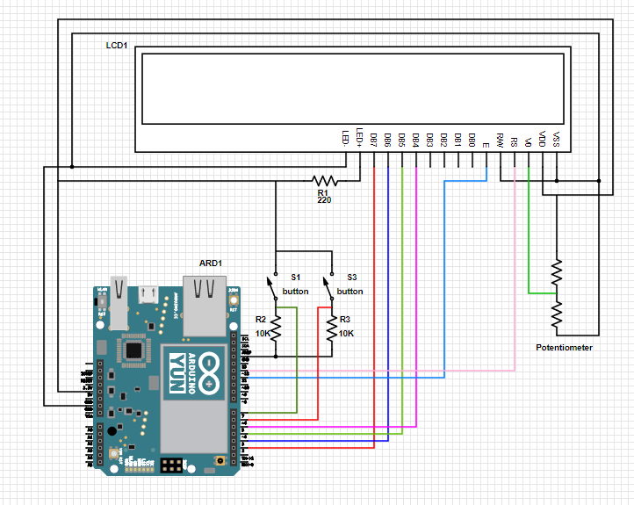

Exercise 2 Circuit
Writing the Program:

Begin by importing the LiquidCrystal library as was done in the previous exercise. Additionally, identify which pins it will need to communicate with.

Prior to beginning the void setup(), a series of variables and initial conditions must be identified. This portion of the code includes new data types such as long and char which allow for extended size variables for greater number storage and to store a character value respectively.

In the void setup(), the start and lap pin inputs can be defined using the pinMode function. Use lcd.begin() to define how large the LCD screen is. Then create the initial screen display for the LCD. Display “Stopwatch” on the first line and “Press Start” on the second line.

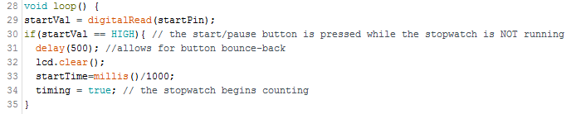
Begin the loop by telling the microcontroller to check the value of the start button. We want the stopwatch to start counting after the start button is pressed which will return a startVal of HIGH. Create a small delay after the button is pressed so there is time for the button to be released before the code is executed. Once the delay is over, clear the LCD screen and record the time the stopwatch begins using millis() and store this variable as startTime. The millis() function is important for this program as it acts as an internal clock of the microcontroller that starts counting in milliseconds when the microcontroller is turned or reset. Set timing equal to true to indicate that the stopwatch is currently counting the time.

While it is keeping track of time, we want the LCD to be constantly updating to display the time in minutes and seconds. To do that, we must define the amount of time which has elapsed. The elapsedTime will be equal to the amount of time that has previously elapsed (like in the case of if the stopwatch was paused and then resumed) plus the difference between the current time defined by the millis() function and the time the stopwatch started/resumed counting.


The seconds is defined as the remainder when the elapsedTime is divided by 60 (which is achieved using %). Meanwhile, minutes is the time elapsed divided by 60 after subtracting the seconds. Add a small delay so the program can keep up.

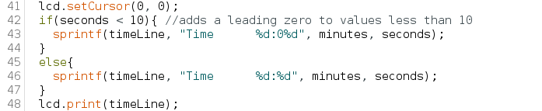
Once the seconds and minutes are calculated, they need to be displayed. The sprintf() function combines text and the values of variables into a single string that we named timeLine. To ensure the clock always has the format MM : SS, a leading zero should be applied to the seconds. For example, we would like the clock to display 12:05 and not 12:5. Have the LCD print timeLine. At this point in the code, we have created a timer that will continuously keep track of and display the elapsed time.
Next, create the Lap feature. The Lap time should indicate how long it has been since the lap button was last pressed. This section of code is still within the while loop of timing=true, so the program is constantly checking to see if the lap button has been pressed. When a lapVal of HIGH is returned, create a delay of 500 milliseconds to allow for the button to be released.
The lapTime variable is defined as the current amount of elapsed time minus the amount of elapsed time when lap button was last pressed (oldTime). After lapTime is calculated, record the time the lap button was pressed by declaring that oldTime = elapsedTime. Add a small delay so the program can keep up.

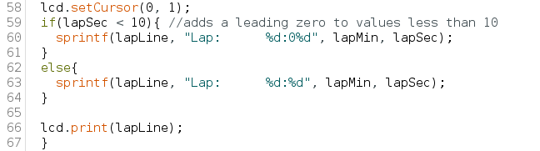
This next block of code simply displayed the lap time on the second row of the LCD screen. Code this like how you did for the time above.

Finally, while timing=true we want the microcontroller to constantly check if the start button is pressed again. When it detects startVal = HIGH again, the stopwatch should pause. Set timing to false so that the stopwatch stops counting and the while loop ends. Record the time that the stopwatch was paused at by declaring that previousTime is equal to the current elapsedTime.

Use the Circuit:

After uploading the code and beginning the program, “Stopwatch | Press Start” should appear on the LCD screen. When you press the start button, the screen should clear and be replaced with the timer which will begin counting. By pressing the lap button, the second line will display the word “lap” as well as your last lap time. How accurate is this timer? Compare your timer with the one on your phone. Does it count seconds at the same rate?

Lab 5 Code Appendix (in order of appearance):
#include – This function works to import an outside library that is necessary for interpreting later codes.

lcd.begin(columns, rows) – starts the LCD library and defines the size of the LCD screen by number of columns and number of rows

lcd.print(text) – communicates text to print to the LCD

random(max#)– a function which generates pseudo-random numbers between 0 & max-1

lcd.clear() – clears the LCD screen and positions the corner in the upper-left corner

lcd.setCursor(column, row) – sets the position of the LCD cursor by setting the point at which text written onto the LCD will be displayed in a (column, row) format

switch…case – similar to an if statement, switch…case controls the flow of programs by allowing the programmer to specify conditions under which a code should be executed. It works by comparing the value of a variable to values in specified case statements. When a cast statement is found that matches the variable value, that code is executed.

break – is used within switch…case to identify the end of a case by exiting the switch statement.

boolean – a data type that is either true or false.

% - (remainder = dividend % divisor) – An arithmetic operator that calculates the remainder when one integer is divided by another For example:
x = 7 % 5 // x contains 2

sprintf(buffer, “text %form”, variable, …) – used to combine text and the values of variables into a single string. The buffer is the variable that the string will be stored in. Within the text, you can include a percent sign followed by a letter corresponding to a data type. After the text, list the values that will replace the %form in the order that they appear. Some of the data types and their corresponding letters are listed below:
- %d: You will obtain an integer output. For example: 5
- %f: You will obtain a floating-point number in a fixed decimal form as your output. For example: 5.5.
- %e: You will obtain a floating-point number that follows the exponential (scientific) format. For example: 5.050000e+01

Lab 4 Grading Rubric:
- Exercise 1 Completed (15 points)
- Exercise 2 Completed (10 points)
- Exercise 3 Completed (15 points)
- Comprehension Questions (10 points)
Grade distribution template (total 50 points)

